Career Development

Satoru Hashimoto

MIS 480 Senior Capstone

Colorado State University-Global- Campus

Chris den Heijer

December 13, 2020

Career Development

This week we registered for the CSU Global Connect community, an alumni networking site that allows students and graduates from our studies here to stay connected with each other via a social networking site. Was not able to get registered as a student, but my alumni registration went right through, some issues with the single-sign-on applet within google.

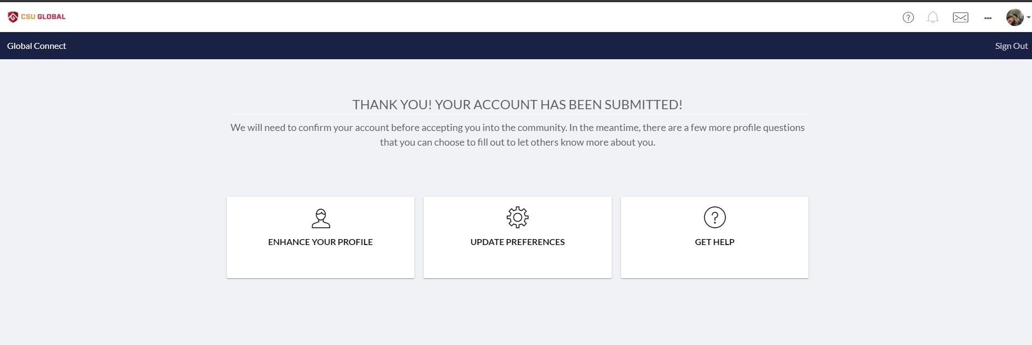

Some advantages of this service include networking in preparation for my hopeful transition n to the data field at my company, as well as keep tabs with my peers who have had notable posts and experience throughout here coursework here at CSU Global.

**Github**

Creating an account and posting my project was relatively easy, and I’m surprised I haven’t been using this as a workspace/revision manager for my coursework since I’ve gotten started. I decided to post my database online with PROC IMPORT instructions to get the dataset into the WORK folder within SAS, from here I ran a Principal Component Analysis (SAS, 2020) of the 8 factors which I believed to be the most significant in pricing risk as an insurance underwriter. I was able to add the code and save my revisions. Maybe this will someday help someone out who needs a decent data set for a school project like me.

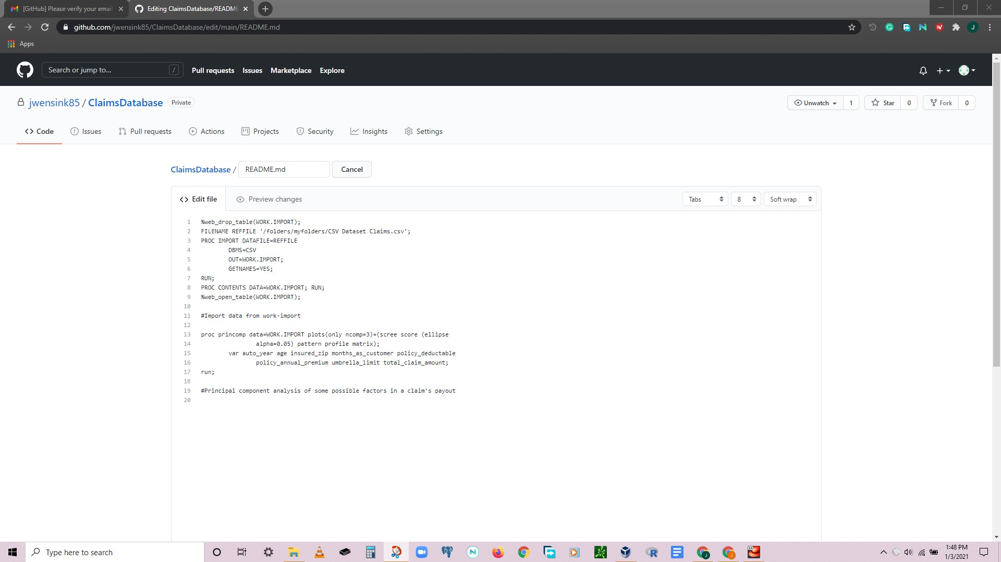

References

SAS. (n.d.). Principal Component Analysis. Retrieved January 03, 2021, from <https://support.sas.com/publishing/pubcat/chaps/55129.pdf>